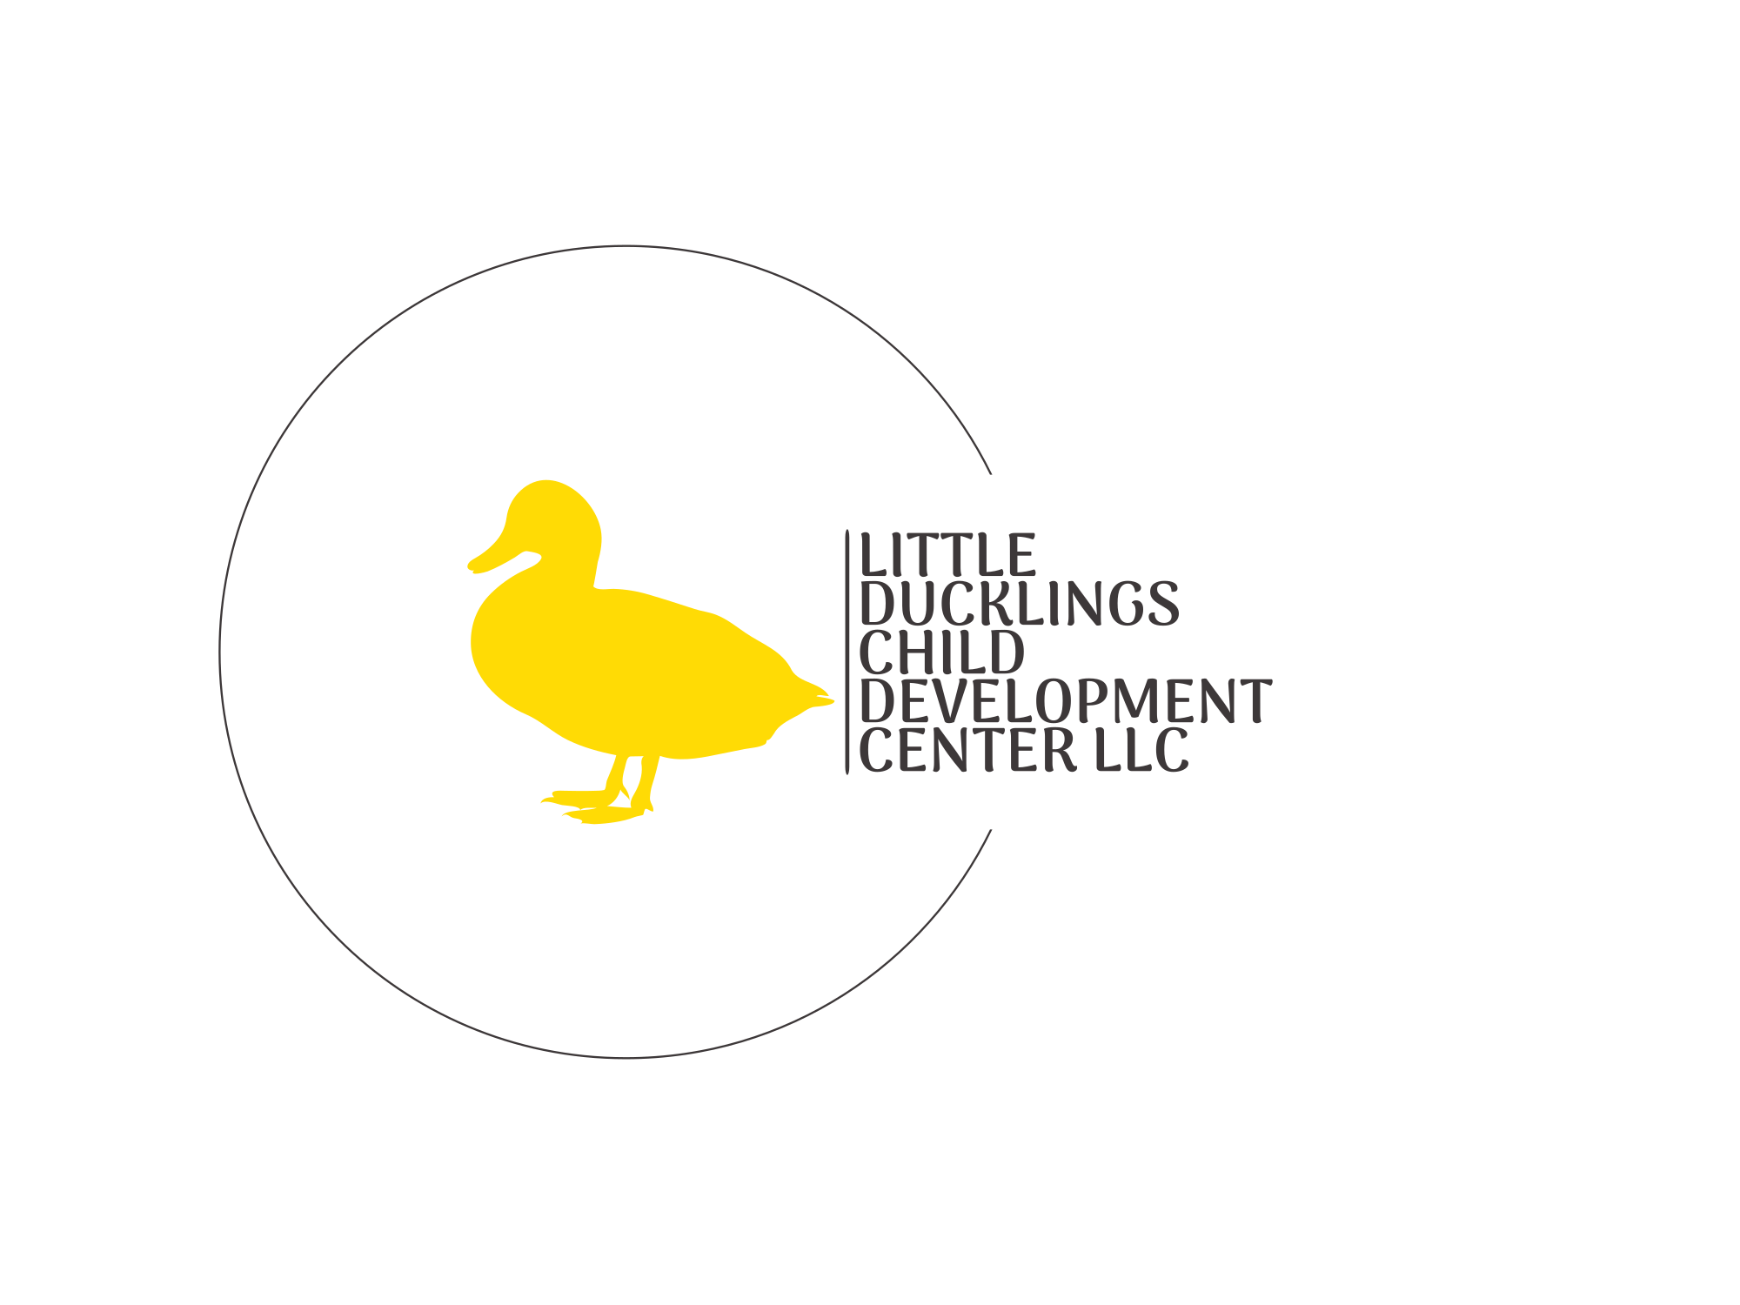
Enrollment Contract 2025 - 2026

777 Vogel St. Boyne City MI, 49712
Keagan Rainey - 231.373.3378 - littleducklings23@gmail.com

Hours of Operation ~
Little Ducklings Child Development Center is open from 7:00 am to 5:30 pm, Monday through Friday.
RATES ~
Childcare Fees:
- Tuition
  - $300/week per child, per week, regardless of days attended
Early Hours Care  7:00a - 8:00a | Weekly Tuition  8:00a - 4:00p | After School Care  4:00p - 4:30p | After School Care  4:30p - 5:30p
$7/day | $300/week | $5/day | $7/day
Child(ren)’s Schedule
Please indicate your child’s regular weekly attendance schedule. To make changes to this schedule, contact Keagan with a 2-week written notice.
Important Notes:
- No credits will be provided for missed days, regardless of the reason.
Child’s Name | In Time | In Time | In Time | In Time | In Time
Child’s Name | Out Time | Out Time | Out Time | Out Time | Out Time

Monday Tuesday Wednesday Thursday Friday

I, ______________________________, agree to pay LITTLE DUCKLINGS CHILD DEVELOPMENT CENTER, LLC the following amount ________________, BY 6:30 PM Friday for the following week, for the days my child (ren) is scheduled
TERMINATION OF CONTRACT
Please initial below to indicate that you have read and understand the following.
_______ Parent Termination of Services - I understand that a two-week written notice is required to withdraw and terminate my financial obligations with Little Ducklings Child Development Center. If I am unable to provide a two-week notice, I understand that I am responsible for paying the equivalent of two weeks of care prior to my child’s last day of attendance.
______ Provider Termination of Services - I understand that Little Ducklings Child Development Center reserves the right to terminate the contract at its discretion. Reasons the provider may choose to terminate the contract include, but are not limited to, the following:
If we determine that we are unable or unqualified to meet the needs of the child without additional staff or support services.
- If the child’s behavior is destructive, uncontrollable, violent, or threatening to other children or staff.
- If a parent’s behavior is threatening or abusive toward the children or staff.
- If the child is unable to adjust to the classroom setting after several weeks.
- If parents knowingly bring a child who is ill or medicated to mask a fever or illness.
- If there is repeated non-compliance with any of the agreed-upon contract terms or center policies.
If Little Ducklings Child Development Center decides to terminate the childcare relationship due to repeated violations of the contract by the parent or legal guardian, the center reserves the legal right to do so without prior notice.
If the provider chooses to terminate the childcare relationship for any reason, at any time, parents will be required to pay for two full weeks of tuition.
To avoid such a situation, parents and legal guardians are required to carefully read and understand the entire contract and policy handbook. If there are any rules or policies that are unclear, parents and legal guardians are encouraged to request a detailed explanation before enrolling their child at Little Ducklings Child Development Center.
PARENT ACKNOWLEDGEMENTS
_______ I understand that Little Ducklings Child Development Center is required to maintain a licensing notebook containing all inspection and special investigation reports. I acknowledge that I have the right to view these reports at any time. I have been informed that the licensing notebook is online, and the center has internet access.
_______ I have read and understand the policies outlined in the Little Ducklings Child Development Center Parent Handbook.

_______ I confirm that I have read and understand the Little Ducklings Child Development Center Parent Handbook. I agree to adhere to all policies outlined in the handbook, including but not limited to:
- Payment policies, Schedule policies, Health and wellness policies, Discipline policy
I acknowledge that it is my responsibility as a parent to familiarize myself with these policies and understand how they apply to my family.
I also understand that Little Ducklings Child Development Center reserves the right to update its policies at the discretion of the owners. I will be notified of any updates and agree to comply with the revised policies.
_______ I acknowledge and agree to the rates and any applicable fees outlined in this contract. I understand that if Little Ducklings Child Development Center needs to adjust rates or amend any policies, I will receive written notification at least 30 days in advance.
_______ I understand that Little Ducklings Child Development Center accepts DHHS childcare assistance payments. However, due to delays in receiving these payments from the state, I agree to the following terms:
- I will be billed weekly and am required to pay my invoice by the regularly scheduled due date (Fridays).
- When DHHS payments are received, they will be applied to my child’s account, which may result in a credit.
- Once a credit is applied to my account, it may allow me to skip a week or multiple weeks of payment, depending on the amount received from DHHS. Despite this, I am responsible for ensuring my account balance is $0 every Friday.
- Late payment charges will apply if my account balance is not cleared by the deadline.
- I understand that I am ultimately responsible for all childcare charges if DHHS or any other assistance agency fails to make expected payments, for any reason.
_______ I understand that failure to make payments for services provided by Little Ducklings Child Development Center may result in alternate collection efforts. These efforts could include:
- Transferring the account to a collection agency, which may impact my credit score.
- Filing a claim against me in small claims court, potentially leading to wage garnishment.
Additionally, I acknowledge that any filing fees or legal expenses incurred by Little Ducklings Child Development Center during the debt collection process will be added to my account and will be my responsibility to pay.
By signing this agreement, the parent or guardian confirms their understanding and acceptance of all terms outlined in this contract and the Little Ducklings Child Development Center Parent Handbook. This agreement is a legally binding contract. The individuals signing below accept full responsibility for payment and formally enter into an agreement with Little Ducklings Child Development Center for the care of the listed child(ren).

_______________________________________________________________________________________________ Responsible Parent/guardian signature Date

_______________________________________________________________________________________________ Little Ducklings Child Development Center Owner Date

